Join us for a screening of

**LONG LINE OF LADIES**

Presented by [your organization here]

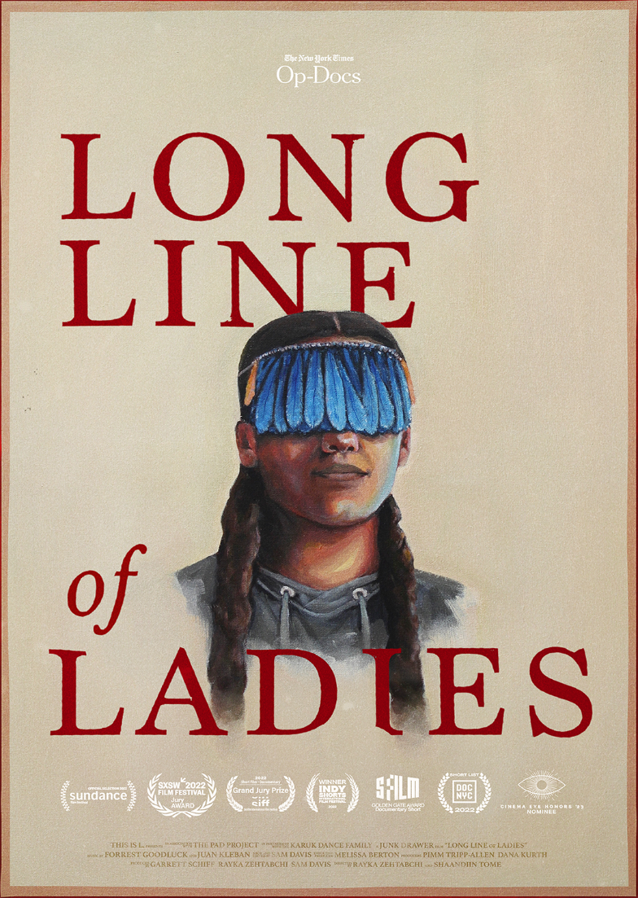

Long Line of Ladies tells the story of a girl and her community  
as they prepare for her Ihuk, the once-dormant coming of age ceremony of the Karuk tribe of Northern California.

**LONG LINE OF LADIES**

A Documentary Film Directed by **Rayka Zehtabchi** and **Shaandiin Tome**

Followed by a (discussion, panel discussion, Q&A, etc.)

When: [INSERT HERE]

Where: [INSERT HERE]

Directions: [INSERT HERE]

RSVP and Contact: [INSERT HERE]