Join us for a screening of

**ALL I SEE IS THE FUTURE**

Presented by [your organization here]

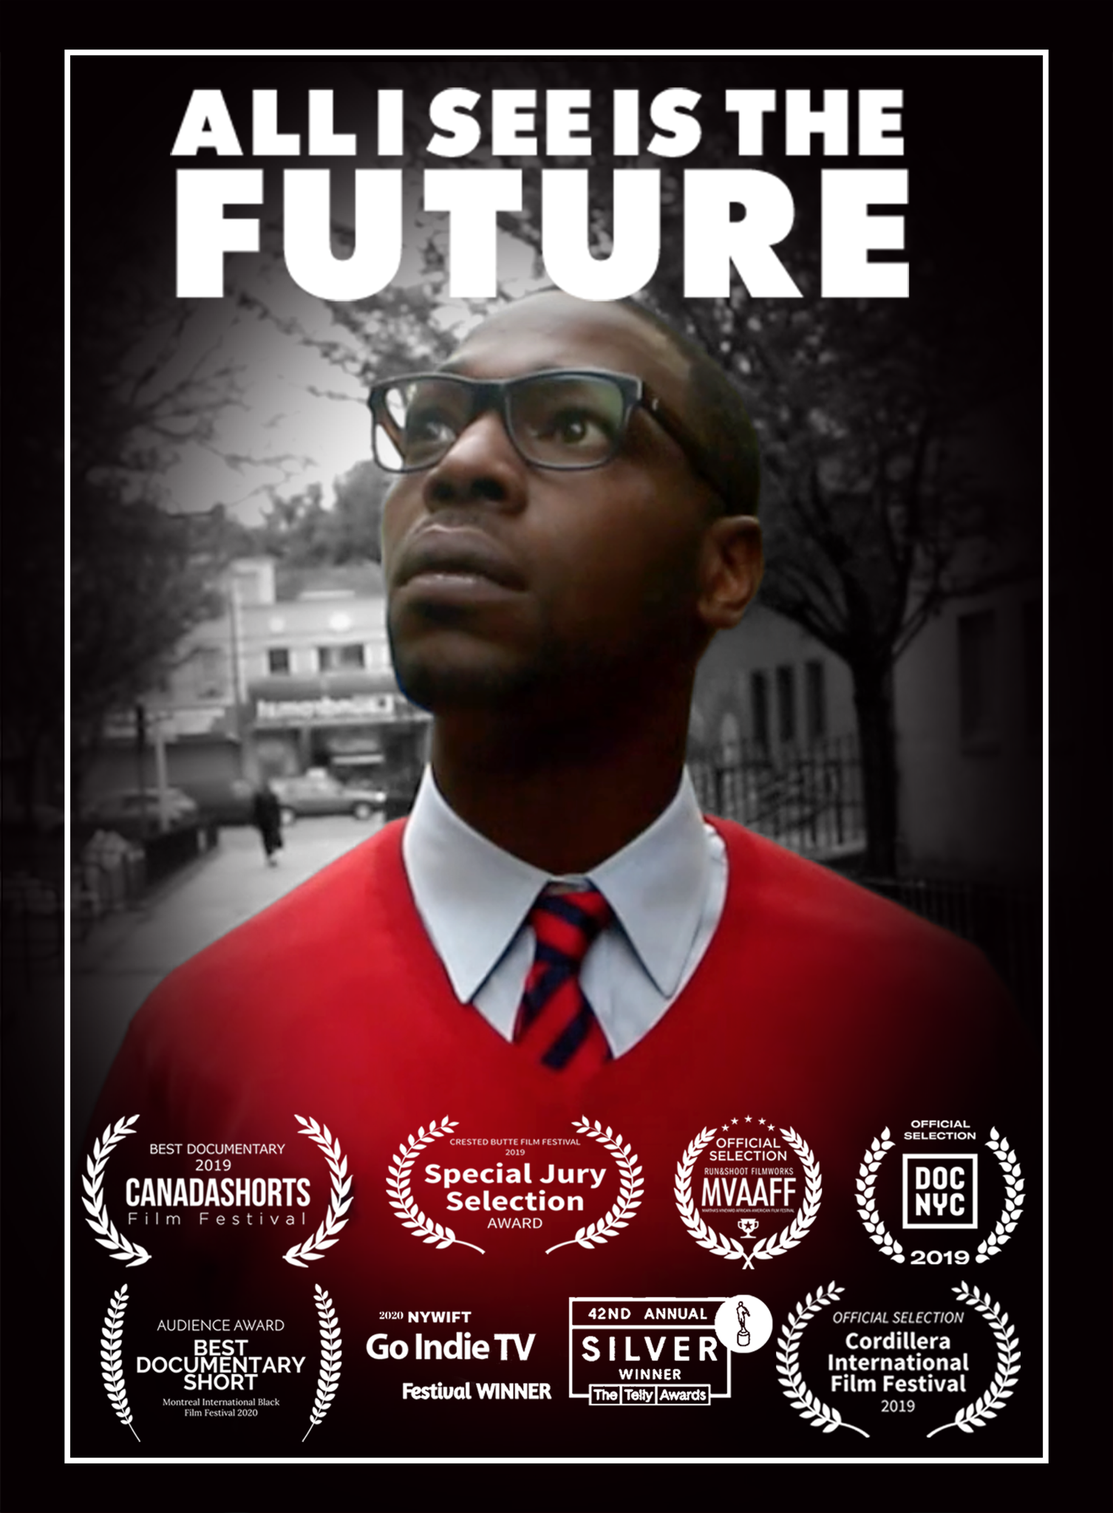

With only “five files and my faith,” Dr. Carolyn Powell opened her first private optical clinic practice in Stapleton, an under-served and dangerous area of Staten Island, New York. A young man showed up at her door looking for work, saying that he had training in optics. She knew from the certificate that the training was from prison. But he swore that “I will be nothing but an asset for you” and she took a chance on him.

Bryant Pearson had been a notorious drug dealer from the Stapleton Projects but with Doc as his mentor, he began to dare to dream the unthinkable – to become a professional. While working at the clinic, he enrolls at the City Tech CUNY School of Optometry, living his motto “All I See is the Future” and together they grow the business with great success. Until he ends up in the wrong place, at the wrong time. With everything at stake, Bryant has to face one last binding tie to his past, so that his future vision can come to fruition.

**All I See is the Future**

A Documentary Film Directed by Nancy Dionne

Followed by a (discussion, panel discussion, Q&A, etc.)

When: [INSERT HERE]

Where: [INSERT HERE]

Directions: [INSERT HERE]

RSVP and Contact: [INSERT HERE]